**Football's NFTs: an enhanced capacity and enormous possibility**

Following the hoopla around NFTs in the arts sector at the start of the year, the wave has spread to the sports industry in the USA and is currently exploding in European football. The "digital certification" of a physical object or image is known as an NFT. The ownership rights to an NFT are entered on the blockchain similarly to how ownership of real estate is recorded at the land registry.

While many people first believed that NFTs were just a passing trend, an astonishing second wave has begun in recent months. Celebrities and major corporations are hopping on the bandwagon more and more. The monthly sales volume has already surpassed billion-dollar levels. Even McDonald's has introduced a burger-themed NFT line. Adidas has also stepped up their game in the NFT space by introducing 3D avatars. The business raised $22 million using 30,000 NFTs in a short period of time. Last but not least, a German football world champion has recently joined Binance, the biggest cryptocurrency exchange in the world, as an NFT.

**Digital trading cards as NFTs**

NFTs can be likened to popular trading cards as follows: For instance, the fan purchases a pack of five cards and learns which players he now owns when he opens the pack. The classification that each card falls under is what makes it intriguing. NFTs on the blockchain make it simple to implement the idea of trading cards, which come in various rarities: Five distinct rarity levels are available on Fanzone's digital trading card platform, including Onboarding (with a circulation of 25,000), Common (3000), Rare (1000), Epic (500), and Legendary (100).

The fan may be confident that his collection is already worth far more than the cost of this first pack if he purchases a 5-pack of NFTs for 10 euros and manages to catch a well-known player in the Rare or Epic category. The extra Special Cards, which are often only published in editions of up to 50 for specific players on specific occasions, are very intriguing. Then, these may be bought straight from the web store. Trading on the secondary market starts after they are all sold, and prices there are typically in the range of 100 euros. Initial results indicate that significant value gains are feasible. After the first sale, a Special Edition Card of Kai Havertz was sold for 1000 euros.

**Fanzone APP**

The Fanzone App, which gives access to the introductory offer, is incredibly simple to use and has a highly user-friendly design. New users who register receive a free pack of five players from the onboarding category right away. These players are accessible in higher editions but have a low value. The next step is for the fan to sign up, make a purchase, and, in the case of a VfL Wolfsburg supporter, buy the Little Wolfs Pack, which contains 5 cards, for 7.99 euros. The Warewolf Pack, which costs 149.99 euros and contains "just 3" cards, is also available to die-hard aficionados. The likelihood of acquiring a rare or extremely rare card is substantially higher, though. In the future, the value of these cards ought to rise more.

Trading via the Fanzone app or marketplace on the LUKSO Blockchain ought to be possible in Q2 2022. For NFT applications, the LUKSO blockchain appears to be highly promising, therefore any delays wouldn't be disastrous. Fanzone may easily and swiftly transfer the NFTs to a different blockchain like Tezos, Flow, Polygon, or Stellar. Fanzone levies reasonable trading costs of 10%, a portion of which goes to the association. A penalty kick game may now be played on Fanzone, taking creativity to a new level. The spectator has the option of picking a goalie or a field player. You may win fantastic digital rewards if you prevail in a penalty shootout.

**Future progress**

The usage of NFTs in the football industry is expected to grow quickly over the next several years. It serves as the ideal platform for the fan experience and a means of tying the supporter to the team. In a few years, many more uses, such as merchandise items, posters, signed autograph cards, applications in NFT-based games, or usage in 3D environments, will be commonplace in addition to NFTs for trading cards or match scene NFTs. The NFT and blockchain industries as a whole should grow into highly profitable revenue streams for clubs.

St. Pauli, which now provides an NFT artwork digitally on each match day, has already made a start. Other teams will likely start offering matchday NFTs soon, such at a pivotal moment in the game or something similar. NFTs on 3D players or objects are also likely to turn into runs. With their use of 3D avatars as NFTs, Adidas and now Werder Bremen have set a strong example. The widespread adoption of NFTs is already anticipated; in actuality, any fan who now makes use of social media is a prospective customer.

Using and setting up wallets is now very simple. The new neo and online discount banks, which have added millions of new members in the past few years alone in Europe, will follow the same trajectory. It is evident that several million football fans will possess NFTs by the time series of individual NFT goods easily surpass the 100,000 mark for various teams. The potential is currently hardly being used.

**Grammarly screenshot:**

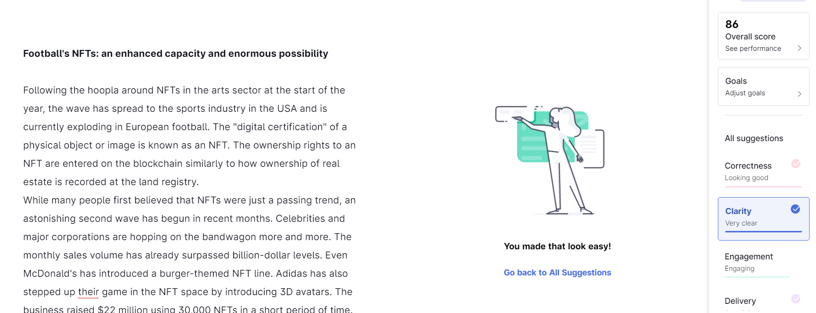

**Plagiarism check screenshot:**

